Binary Search Tree

Student Name
Institution affiliation
Instructor
Date

Binary Search Tree
A binary search tree (BST) has each node of a binary tree with a comparable key and satisfy the restriction that the key in any node is larger than the keys in all nodes in that node's left subtree and smaller than the keys in all nodes in that node's right subtree. The BST is used to sort elements in the data structure by their values. The process is recursive thus searching and sorting value in a data structure ( Patel, 2018, p.166 ).
The BST for 1,2 3, 45,6,7 will be as shown in the figure below. All the subtree nodes will move to the right since the next node has a larger value than the current node.
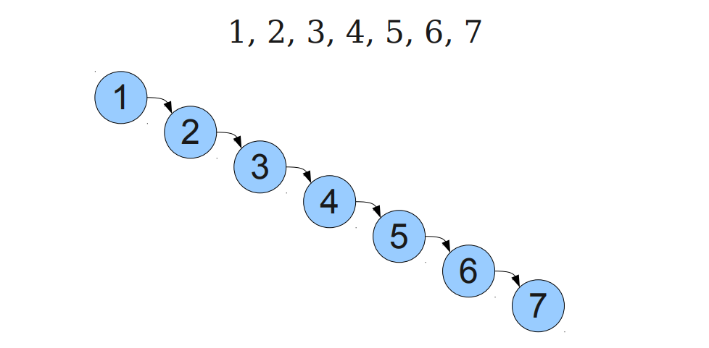

The advantage of recursive BST is that elements in the data structure are sorted in a pattern that is like the walking tree due to iterate over the element.
The main disadvantage is that it requires values to be sorted to avoid all the values failing on one subtree. Sorting will ensure that values are even the binary search tree.

References
Patel, M. (2018). Data Structure and Algorithm With C. Educreation Publishing.

